2019/2020 Buena High School Mini Bulldog Cheer Camp 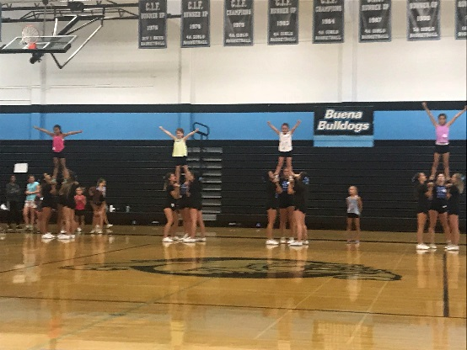
Buena’s Mini Bulldog Cheer Camp program provides youth cheerleaders (current and aspiring) a hands-on experience with the fundamentals and techniques of high school cheerleading. Join us for the fall session at an exciting one day camp on at Buena High School to train with the Buena cheer team! Participants will learn cheers, stunts, and cheer safety with one-on-one and group coaching, and will get to perform with the team for part of one of the Buena home basketball games. This is a great opportunity to experience the excitement of high school cheerleading for those already involved in the sport, or those that might be considering it for high school!
Camp Date January 11, 2020
Age Group Kindergarten through 8th grade
Cost $45 (Includes a Mini Bulldog Cheer Camp T-shirt)
Liability waivers will be required to be filled out the morning of camp.
Registration information: go to www.buenahighschoolcheer.com and register online. If you register and pay online please email Coach Lanski at lauren.lanski@venturaedu.org and advise her that you have registered and the name of your child.
The other option is to fill out a registration form and drop off at Buena High School office.
Name of Camper___________________________________________________
Grade___________
Name(s) of Parent/Guardian__________________________________________
Email____________________________ Phone number____________________
If you pay by check please make check written to: Buena ASB. Please ask receptionist to leave information in the box of Mrs. Lanski.

