BUENA HIGH SCHOOL CHEERLEADING HANDBOOK AND CONTRACT
2022-2023

Mission Statement
The mission of Buena High School Cheerleading is to develop world-class athletes that represent Buena with enthusiasm and character, both at school and in our community. We are dedicated to promoting school unity, pride and engagement, with a team deeply committed to inspiring others through outstanding athleticism, performances, leadership, and sportsmanship.
Our legacy of excellence is based on the development of well-rounded students with a combined focus on academics, integrity, discipline and safety. We set team and personal goals which guide us to continual improvement, with an unwavering commitment to inclusivity and kindness.

BHS Cheer Program Rules and Regulations:
Cheerleaders understand that teamwork and the maintenance of discipline is the key to the success of the cheer program. Adherence to the cheer program rules and regulations is vital to achieving our goals. All members realize that the manner in which they conduct themselves, in or out of uniform, directly reflects on the entire team and the school.
It is recognized that the protocols in this handbook are necessary to maintain morale, discipline and effective learning. Consistent enforcement of them is also necessary to ensure the safety and general well-being of each individual cheerleader. It is a privilege, not a right, to be on the BHS Cheer team and may be revoked by the coaching team or school personnel when an individual violates the requirements set out in this handbook.
We expect you to put the team first, and respect the coaches’ decisions made for the good of the team. A cheerleader’s position or participation in a dance, cheer formation or stunting pod is not guaranteed and is at the complete discretion of the coaching team.

Important Dates:

TRYOUT CLINICS
When: Tuesday-Friday, February 8-11th 3:30-5:00pm
Who: Invited/Eligible Students ONLY

TRYOUT REQUIREMENTS
- Participate in all clinics.
- Be prepared in appropriate athletic attire: T-shirt, shorts (no jean shorts), athletic shoes and hair pulled back. Improper attire (spaghetti straps, midriff shirts, short shorts, etc.) will exclude the student from participating.
- No cheer oriented clothing.
- No gum.
- BE ON TIME. We will start promptly at 3:30 and end at 5:00. Friday may run longer.
In order to try out all candidates (and a parent/guardian) must agree that all decisions are final and will be respected and not contested. Judging will be done by qualified personnel.

MANDATORY ZOOM TEAM/PROGRAM LAUNCH MEETING:
When: Monday February 21 6pm via Zoom.
Who: Students that have made the team AND parents/guardians

ELIGIBILITY
- All cheerleading candidates and parents must sign the cheer contract stating that they agree to and are aware of the amount of time, expense, commitment, program rules and regulations as described in this handbook and responsibilities required for participation.
- Please also read the BHS student handbook for athletic eligibility.
- All cheerleaders are responsible for completing the entire Register My Athlete registration, including uploading a current physical clearance in order to be allowed to practice or perform.
- Maintain a GPA of at least a 2.0 on a 4.0 scale.
- Cheer is also a GRADED class during the fall, and possibly, the spring semester. Inability to follow the responsibilities can result in being dismissed from the team and dropped from the class with a lowered grade and/or possibly no credit.
- School suspensions and SARB notifications can also result in immediate dismissal from the team.
- Behavior referrals will result in being benched.
- Members will not be involved in any school activities that interfere with cheer team.
- Students who are dismissed from or quit the team are ineligible to try out for the following academic school year at BHS.
- Junior Varsity squad can consist of students entering the 9th and 10th grade.
- Varsity Squad can consist of girls entering the 11th and 12th grade.

CONDUCT

By being a part of the cheer team, exemplary behavior is expected at all times, anywhere in the community, on and off social media, and at all school functions where you are recognized as a representative of BHS.
- Abstain from the use of illegal drugs, alcoholic beverages, tobacco, profane language, harassment/bullying, and to follow the conduct guidelines listed in the Buena Student Handbook.
- Promoting good sportsmanship by way of example is required at all times.
- We expect our team members to be positive and support one another.
- Members must cooperate with all faculty members, team members, game officials, and coaches.
- Cheerleaders must display proper behavior in class. This includes being on time, good attendance and demonstrating integrity.
- Every attempt will be made to discipline fairly and equally, and to make consequences of actions known ahead of time. Parents will be kept informed of issues. Severity of, or repeated offenses may dictate harsher action.

ABSENCES
Cheerleading is unlike any other sport. We do not have substitute members, so your participation is critically important. Illness or other extreme emergencies are the only valid reason for missing practices and games.
- One person being absent affects the entire team. It is important not to inconvenience and affect the practice time of the entire team by being absent.
- Absences will be excused in the event of a personal illness with medical excuse, a school or function planned ahead, family emergency, or death of a family member. Family vacation will be excused if planned and scheduled ahead with coaches at least 2 weeks prior to the vacation.
- If you are going to be late or miss a practice/game you need to give two weeks’ notice.
- Absences will be reviewed on an individual basis and may result in loss of position/participation in performances or cheers.

SAFETY
Safety is our first priority. All safety rules are enforced and followed at our practices and games. Any cheerleader violating safety policies and rules will be subject to discipline.
- No excessive horse-playing.
- Never stunt or tumble when a coach isn’t present. No stunts are ever allowed to be attempted without coaches’ permission first.
- Cheerleaders are responsible for a certain amount of their own safety and protection during practices and games. Wraps, braces, or tapes are to be worn when needed.

SUMMER/FALL
It is imperative that cheerleaders attend and participate in ALL summer activities and events including camp, clinics, fundraisers and assemblies.

EXPECTED EXPENSES FOR CHEERLEADERS
- Camp: Approximately $300. We may not have cheer camp this summer, still TBD
- Uniform: Approximately $600. We will be using the same uniform as last season
- Socks: white hidden socks only.
- Cheer team and individual photos: Approximately $30.

UNIFORMS
Uniforms must be cared for properly. Do not dry clean. Machine wash in cool water, hang to dry.
Your uniform consists of: skirt, shell, crop, brief, bow, white no show socks, cheer shoes, poms, warmups.
- Cheerleaders will not loan out any piece of their uniform to anyone. Your uniform is only to be worn at cheer activities/events.
- Uniforms may not be worn casually or with “normal” clothes.
- In uniform means the entire uniform—no substitutions of warmups or other items of clothing
- Uniforms may be altered with permission of the coaching team. Do not cut the material. You will be responsible for any uniform that is damaged or lost.

GAMES
- Members are required to arrive at scheduled time before the game. GAME READY, hair done, uniform on, ready to warm up.
- You must know all the cheers, chants, and routines for the game. Cheerleaders will be benched until all material is learned. This will take place on your own time.
- Members are required to be dressed in full uniforms at all times, unless instructed otherwise.
- Cheerleaders must bring all parts of warmup outfit to all games.
- Makeup should be worn in moderation – to coach’s discretion.
- No jewelry.
- No artificial nails. Nails must be athletic length – no longer than the end of finger tips.
- Any cheerleader suspended from or sitting out a game for any reason will sit collectively with the coach in full uniform game ready.
- All cheerleaders are required to use BHS transportation to and from all games and camps. Go as a team, leave as a team.
- When attending assigned games, you will sit collectively with the coach in the assigned area
- Cell phones need to be put away during games and practice.
- It is your responsibility that ALL trash and equipment is cleaned from out area before you leave.
- Coaches can remove you at any time and place you on a different team/pod at any time based on performance/skill/needs of the team.

PRACTICE
- Cheerleaders must arrive to practice on time, wearing proper clothes and shoes.
- A current physical good through the entire season must be on file before you can participate in practice/games.
- There is no chewing gum at practice.
- No jewelry, nails need to be athletic length, no acrylics.
- Cell phones are off and put away.
- If you are late or miss a practice, consequences will apply.
- Practice schedules may change based on the needs of the season.

EVENTS
- Actively participate in all fundraising and community service activities.
- Make and post spirit signs.

FOR THE PARENTS/GUARDIANS
Parental/Guardian Involvement: Our successful program relies on the talent and hard work of the cheerleaders, as well as the support and participation of the families. We understand that most parents work, and many families have more than one child with extracurricular activities and sports that require time, money and participation for fundraising and events. Cheerleading is a sport, and moreover, it is a highly demanding sport that covers more than one season: our team cheers for the entire football season and basketball season, which means weekly (or twice weekly) games. This sport takes commitment, both on the part of the cheer athlete and the family. You’ll find that involvement in cheer provides incredible opportunities for your child to hone skills in teamwork, and provides discipline, athleticism, leadership training and self-esteem.
Time commitment: The team practices after school most weeks Monday through Friday, including during summer. We expect to have part of the month of July off this summer TBD. We host and perform at home games for football and basketball girls’ and boys’ teams and also travel to support our teams on the road. It’s important to understand that being a cheerleader is more than wearing the uniform and performing at games—these girls train rigorously, and do so for their own safety and for them to coalesce into an incredible performance team. This takes time, effort and strength, and these things are not achieved overnight, nor do they remain without commitment to ongoing practice.
Self-advocacy: If your cheerleader has a question, or a request, or if a problem arises, our expectation is that the cheerleader comes to the coaching team for help resolving it. Parents are naturally welcome to come to the coaches with questions or concerns, but our expectation of these mature student athletes is that they first self-advocate, speak up for themselves and participate in finding solutions to any issues. Our coaching team is here to help! We would like to encourage an open and honest flow of communication, and expect our athletes to be mature and accountable.
Fundraising: Our program is self-funded—that means our team works together each season to raise money needed for some uniform costs, important and costly equipment, to help pay for a percentage of training camp, and for the end of year awards banquet, to name just a few considerations. That means that signing up for the cheer team means agreeing to participate as part of the team and parent group to volunteer time and effort for fundraisers throughout the year. Being part of this team means everyone working together. Funds raised are not for individual cheerleader’s accounts—rather, everyone participates together in raising money needed that then goes into the general cheer program account.
Here are a few of the scheduled fundraising projects, with more details below:
Date | Fundraiser | Type
February 28 2022 | Snap! Raise | Send emails to friends and family
Summer 2022 | Sponsorship Drive | Seek local businesses interested
Fall 2022 | Cheer Mini Camp Football | Sign up local kids
Spring 2023 | Cheer Mini Camp Basketball | Sign up local kids

February 28th Snap! Raise
We kick off our new season with a fundraiser that is outreach to each cheerleader’s friends and family. Snap! Raise is a social donation platform that enables our team to receive donations from our networks, communities, and supporters. The program uses the power of social media with a safe, fun and interactive approach. At the Zoom kickoff meeting on February 28th, cheerleaders will come prepared with 20 or more email addresses of their biggest fans and supporters, and they’ll be entered during the meeting into each cheerleader’s individual account. The contacts are strictly private and protected. The Buena Cheer program staff will track each cheerleader’s participation and there are prizes for the most money raised. This is a fun and easy fundraiser, and has been very successful for us so far!

Dates TBD, depending on Covid restrictions (Fall and Spring): 2 Cheer Mini Camps (football/basketball)
Buena’s popular Mini Bulldog Cheer Camp program provides youth cheerleaders (current and aspiring) a hands-on experience with the fundamentals and techniques of high school cheerleading. This is a one day camp put on by the cheer team, one for the football season, and one during basketball. Each cheerleader is asked to sign up at least three cheer mini campers for each fundraiser, and to circulate the camp flyer. Camp participants will learn cheers, stunts, and cheer safety with one-on-one and group coaching, and will then get to perform with the team for part of a Buena home game. This is also a great opportunity for community service hours for our cheerleaders to prepare for college.
BUENA HIGH CHEER CONTRACT 2022-2023
Signing this contract indicates your desire and commitment to be a member of the Buena High School Cheer Team and to support the following standards:
Signing this contract indicates student and guardians have read, understand and will abide by the rules and regulations set out in the Buena High Cheerleading Handbook.
Full Name__________________________________________
Grade in 2022/23__________
Parent’s/Guardian’s Names____________________________________________________
Parent Phone_________________________Student phone________________________
Parent email:______________________________________________________________
We have reviewed the required time commitment for the BHS Cheer Team. We have read the guidelines for cheerleading tryouts, and consent to having our student participate in the process. We will meet the tryout requirements and accept all placement decisions.
We confirm that our student has no health problems which would be aggravated by or make him/her unable to participate in the cheer team activities.
We have read, understand, and am willing to fulfill all tryout and membership requirements of Buena Cheer. We agree to accept all placement decisions. We realize that any violation of the behavior standards in the handbook will result in consequences, including being benched, removed from stunt or dance pods and/or immediate dismissal from the cheer team.

___________________________ has my permission to try out for and, if chosen, be a cheerleader at Buena High School. I understand and agree that he/she must observe and abide by the Cheerleading Contract and Handbook requirements or face dismissal from the team.
Parent/Guardian Signature: ________________________Date: ______________
Student Signature: ______________________________ Date: ______________

Stay connected with Buena Cheer!
Team website: https://www.buenahighschoolcheer.com/
Buena Cheer Facebook page: https://www.facebook.com/BuenaHighCheer
Varsity Instagram: https://www.instagram.com/buenavarsitycheer_/
JV Instagram: https://www.instagram.com/buenajvcheer/
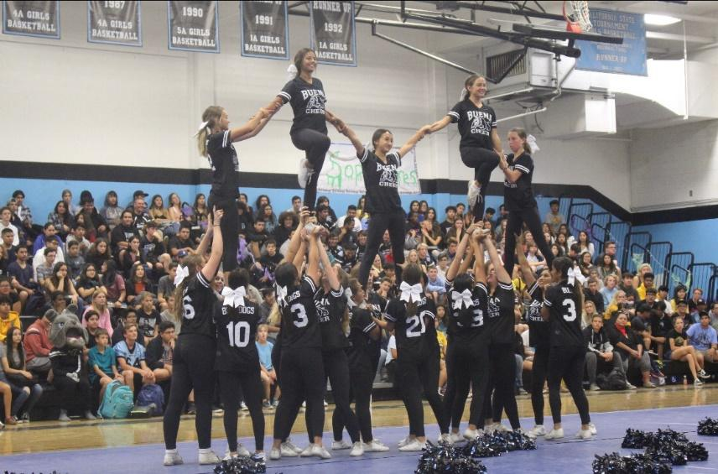

Lauren Lanski
Health Education Teacher &
Advisor/Head Coach of Buena Cheer Program
Room 41
805-289-1826 ext. 2141
Lauren.Lanski@venturausd.org

